**OOP CA2 (15%)**

**Due: Monday 2/12/24 @ 9am**

Create a program which mimics a card game of BlackJack or 21. The rules are you need to have a hand less than or equal to 21. An Ace is worth 11 or 1. Jack, Queen and King are all worth 10. All other cards are their face value. The dealer deals you two cards and you can decide to stick or twist. You can receive a card until you stick or go bust (over 21). When you have decided to stick the dealer deals two cards. If he has less than 17 he takes another card and repeats until he has more than 17 or is bust. You then compare your score with the dealers, the highest wins. More details on the game and rules are available at this [link](https://www.pagat.com/banking/blackjack.html). You are also required to add an additional feature of your choice to the game. See below for a screenshot of how this program works. The screenshot is simplified, impress me with your creativity.

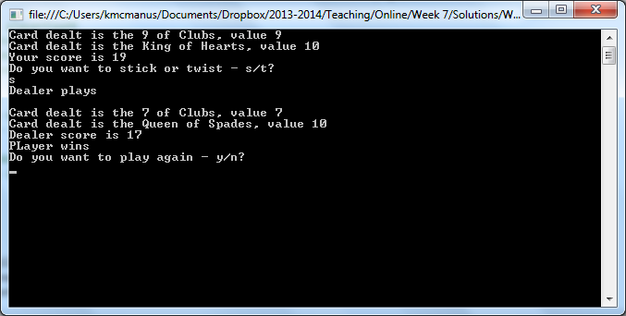

Marking Scheme

|  |  |
| --- | --- |
| Algorithm | 15 |
| Use of methods | 10 |
| Use of arrays/lists | 5 |
| Random | 5 |
| Loops | 5 |
| Selection | 5 |
| Appropriate types (int, bool etc) | 5 |
| Additional Feature | 10 |
| Clarity of code (Space, comments, naming) | 10 |
| Functions as it should with test data | 5 |
| Formatting of output | 5 |
| Use of Classes/Objects | 30 |
| Use Github | 15 |
| Student understanding of code | 25 |
| Total | 150 |